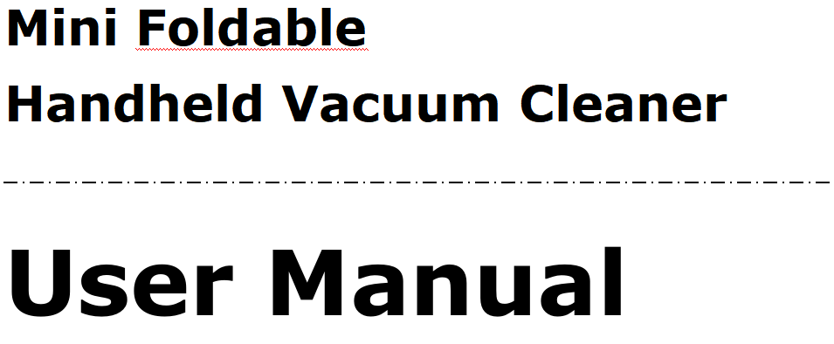

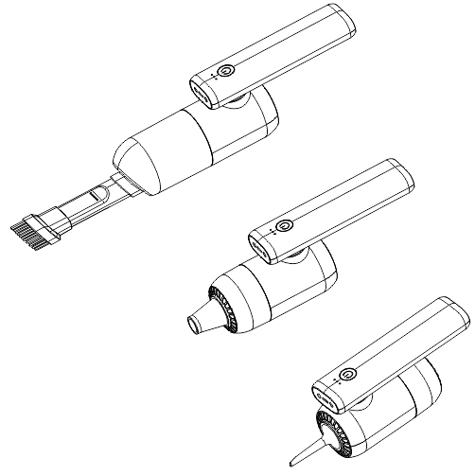

# Preface

# Hello:

# Thank you for purchasing our product. For your convenience, please read the manual carefully and follow the steps in the manual. No matter what kind of problems you encounter during use, please contact us in time, we will always be there to help you solve the problem.

# Warning: Do not place this product in a fire or high-temperature container to avoid fire or explosion.

# The company has the right to modify and improve any products described in this document. At the same time, the company maintains the right to continuously update the content of the product, and all content is subject to the actual product without prior notice.

# 

**Maintenance and cleaning**

* ** Do not expose this product to the sun.**
* ** Do not use this product in places with high humidity such as bathrooms.**
* ** This product is not waterproof, please do not wash it with water.**
* ** Do not wipe the surface with chemical agents such as alcohol, thinner or benzene.**
* ** A dirty socket will cause poor contact, power failure, and failure to charge. Please clean it regularly.**
* ** Please use a regular brand qualified charger.**
* ** If there is a quality problem, please do not disassemble it by yourself.**

**Product Introduction**：

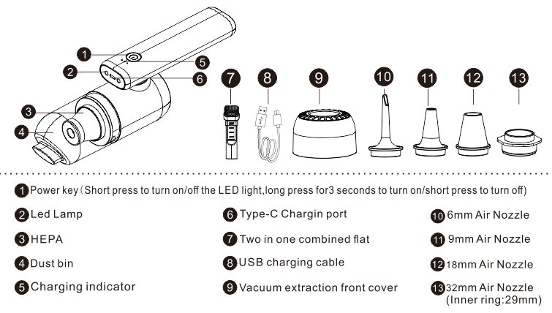

**Charging instructions：**

This product uses a Type-C USB charging cable. One end of the charging cable is connected to the charging port at the bottom of the handle, and the other end is connected to the output 5V 1A charger.

**Features：**

This product adopts a high-speed turbine pure copper core large motor with strong suction power, which can easily suck dust, residues, paper scraps, peel, soot, etc. This product is compact and convenient. The handle can be rotated by 180 degrees to easily suck dust in hard-to-clean corners. The front flashlight illuminates every dark corner.

**Features：**

1. The handle is 180°rotatable, easy to use.

2. Visual dust box design，no dust spills when tilted.

3. Wireless and portable, suitable for home and car use.

4. Compact size and strong suction,easy to carry and place.

5. Washable filter, can be used repeatedly.

6. Type-C universal interface charging cable.

**Accessory installation method：**

1.Wide nozzle: efficient cleaning of dust, fur, hair in the gaps between mattresses, sofas, windowsills, etc.

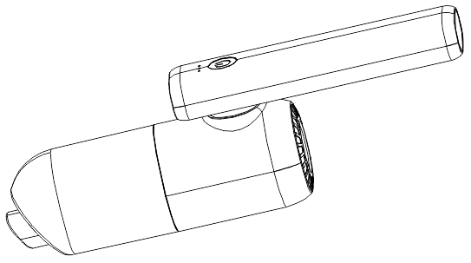

2. Flat long nozzle: suitable for cleaning various narrow spaces such as car doors, seats, cup holders, and home windowsill slots.

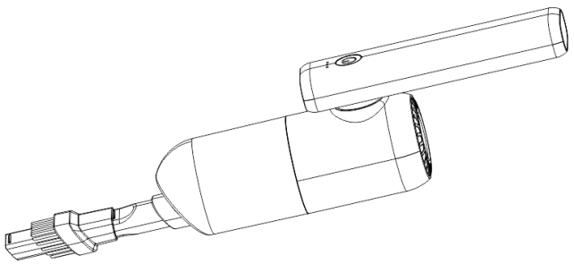

3.Brush nozzle: suitable for cleaning lamps, keyboards, air outlets of the center console in the car.

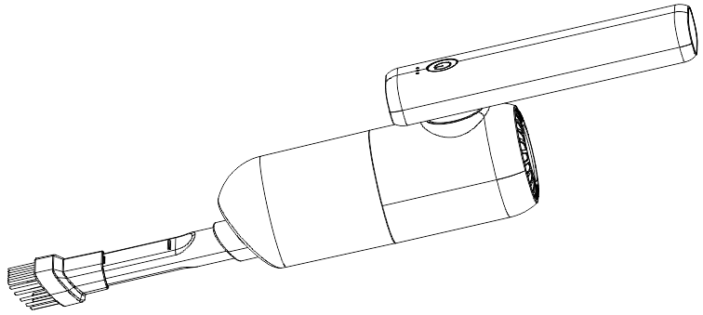

4.Inflate with a vacuum: comes with 4 different shape nozzles, they can be use as mini vacuum, air duster and inflator. Choose the right nozzle to inflate swimming rings, air mattress, balloons, etc. Blows away dust and debris from keyboards, phone and computer crevices.

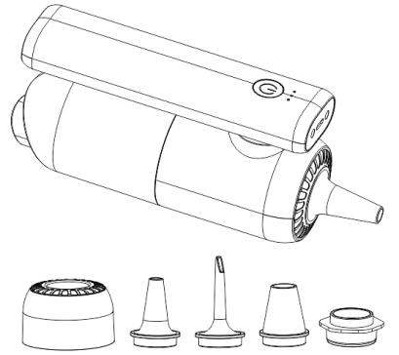

5.Vacuum pumping: equipped with four different mouth shape, choose the appropriate mouth shape can vacuum bag to vacuum, you can give swimming rings, air mattress, balloons, air cushion, inflatable toys air.

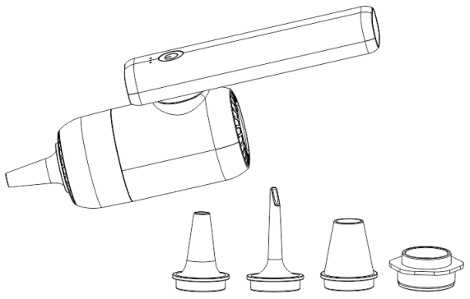

**Vacuum nozzle installation steps:**

1. Remove the dust box from the handle.
2. Put the round vacuum lid on instead.
3. Choose the right nozzle and install the nozzle on the lid.

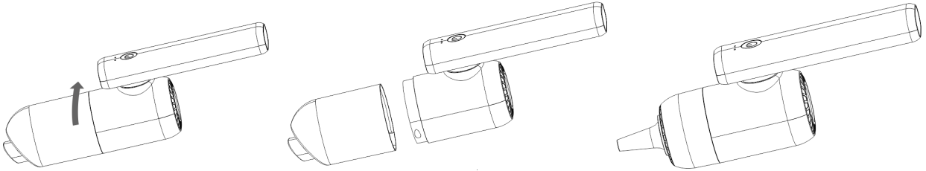

**Product parameters：**

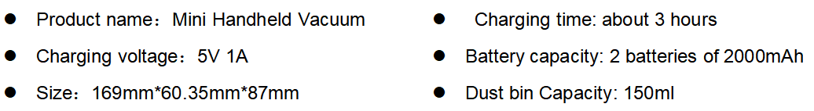

**After-sales service:**

To provide customers with high-quality products and satisfactory service is our pursuit.

If the product you received is defective, please contact us first, we will send a

replacement or provide a full refund for you.

**Customer Service E-mail:**